A

Project Report on

***Online Clinic Management System***

Submitted in partial fullfillment of the requirement of the degree of

***BACHELOR OF TECHNOLOGY***

Submitted by

Ayan Sharma (18etccs015)

Lakhan Prajapat(18etccs057)

Computer Science Engineering

TECHNO INDIA NJR INSTITUTE OF TECHNOLOGY ,UDAIPUR

ACKNOWLEDGEMENT

We have taken efforts in this project. However, it would not have been possible without the kind support and help of many Faculties. We would like to extend my sincere thanks to all of them. We highly indebted to **Mr. Aditya Maheshwari** for their guidance and constant supervision as well as for providing necessary information regarding the project & also for their support in completing the project.

We would like to express my gratitude towards my parents & member for their kind co-operation and encouragement which help us in completion of this project. Last but not least. many thanks go to the head of the project, Mr. Aditya Maheshwari whose have invested his full effort in guiding the team in achieving the goal. We have to appreciate the guidance given by other supervisor as well as the panels especially in our project presentation that has improved our presentation skills thanks to their comment and advices.

We would like to express our special gratitude and thanks to all above mentioned people for giving us such attention and time. Our thanks and appreciations also go to our colleague in developing the project and people who have willingly helped us out with their abilities.

Ayan Sharma

Lakhan Prajapat

DECLARATION

We hereby declare that the project work **ONLINE CLINIC MANAGEMENT SYSTEM** submitted, is a record of an original work done by us under the guidance of **Mr. Aditya Masheshwari** Assistant Professor, Department of Computer Science, **Techno India NJR, Udaipur** and this project work is submitted in the partial fulfilment of the requirements for the award of the Degree of Bachelor of Technology. The results embodied in this report have not been submitted to any other University or Institute for the award of any degree or diploma.

Ayan Sharma

Lakhan Prajapat

TECHNO INDIA NJR INSTITUTE OF TECHNOLOGY ,UDAIPUR

**Department of Computer Science**

**Certificate by Examiners**

Certified that **Ayan Sharma And Lakhan Prajapat** has carried out the project work presented in this report entitled **ONLINE CLINIC MANAGEMENT SYSTEM** for the award of **Bachelor of Technology** from **Techno India NJR**, **Udaipur** under my supervision. The report embodies results of original work, and studies are carried out by the students and the contents of the report do not form the basis for the award of any other degree to the candidate or to anybody else from this or any other University/Institution.

Internal Examiner External Examiner

Date:-………………

ABSTRACT

“**Online clinic management system**” is to manage the management system of the clinic. The main objective is to develop the software that covers all the aspects of the management and operations of clinics. It enables healthcare providers to improve operational effectiveness, reduce costs, reduce medical errors, reduce time consumption and enhance the delivery of quality of care.

Clinic is a web-based application that covers all aspects of the management and operations of clinics. This website covers features of Doctors Details, Patients Records, Online appointments, Patient reports, billings, Clinical tests, Medical store billings, etc. The project supports to the administrator to access the complete application. The patient takes an appointment through Online/Offline, Doctors manages patient reports, Receptionist approves patient’s appointment and makes bill, and medical Store Administrator can view suggested prescription.

Each patient of the Polyclinic has a unique patient ID and password. By entering a user ID and password patient can log in to the system. Polyclinic website and the patient can view Appointment details, Patient reports, clinical tests, Billing, etc. Over the years Arogya Multi-specialty clinic as shown tremendous interest and services towards the public by conducting several camps like diabetic camp, cancer camp, joint pain camp to bring awareness among the masses. And it also provides a medical check-up facility called ‘Arogya Check-up’ for a comprehensive Health check-up program. In future rural camps will be conducted by the doctors for the benefit of poor patients.

**TABLE OF CONTENTS**

**Contents Page**

**no.**

CHAPTER 1 INTRODUCTION 1-3

1.1 Project Detail 1

1.2 Project Scope 2

1.3 Hardware and Software 3

CHAPTER 2 TECHNICAL FEASIBILITY 4-7

2.1Technology Description 4-7

2.1.1HTML 4

2.1.2CSS 5

2.1.3BOOTSTRAP 5

2.1.4MY SQL 6

2.1.5PHP 7

CHAPTER 3 ER DIAGRAM AND DFD 8-14

3.1 E R Diagram 8-9

3.2 Data Flow Diagram 10-14

CHAPTER 4 BACKEND DESIGN 15-22

4.1 Data Dictionary 15-22

4.2 Database Tables 23-26

CHAPTER 5 FRONTEND DESIGN 23-30

CHAPTER 10 FUTURE SCOPE 31

10.1 Future Scope CHAPTER 11 CONCLUSION 32

**CHAPTER 1**

**INTRODUCTION**

**1.1 Project Detail**

“**Online clinic management system**” is to manage the management system of the clinic. The main objective is to develop the software that covers all the aspects of the management and operations of clinics. It enables healthcare providers to improve operational effectiveness, reduce costs, reduce medical errors, reduce time consumption and enhance the delivery of quality of care.

Clinic is a web-based application that covers all aspects of the management and operations of clinics. This website covers features of Doctors Details, Patients Records, Online appointments, Patient reports, billings, Clinical tests, Medical store billings, etc. The project supports to the administrator to access the complete application. The patient takes an appointment through Online/Offline, Doctors manages patient reports, Receptionist approves patient’s appointment and makes bill, and medical Store Administrator can view suggested prescription.

This online clinic management system was developed from PHP, Javascript, HTML, Jquery, CSS, and so on. Moreover, this is a simple clinic app to help doctors to make appointments and the patient to records their details. This project can be run in the localhost by making a database “ocms”. However, the tables are created automatically by the internal function.

This software gives you perception in your hospital pastime and maintains historical data of every single patient. Above all, you could keep patient’s information about encompass tobacco utilization, alcohol intake, surgical and obstetric records, and genetic diseases. In other words, it is smooth to apply and makes you emerge as more organized.

**1.2 Scope**

Clinic Management System for UTeM is a system that can help the clinic to manage their daily activity. This system help reduce the problems occur when using the manual system. This system enables doctors and clinic assistant to manage patient records, medicine stock, and appointment and produce reports. The system is develop

due to the problems that exist when using the manual system. Data inconsistency, data mix with other data and problem regarding reporting is the main problem that the user is facing. Due to that, this system is develop to overcome the problems. This system is easy and simple to use by the user. Other than that, the system is user-friendly and it can help the clinic to manage their activity and at the same time overcome the problem.

Clinic management is introduced to optimize clinic's operation. Because of huge changes in management nowadays, management for clinic is important due to the widely spread of technology. This System is proposed to manage the clinic's operation efficiently. The process in developing the system include clinic . The area consists of the user in clinic which is doctor and clinic assistant. Basically there are no such systems in the clinic. The system use before has caused a lot of problems to the user. Due to that, using manual system seems to be the only solutions in managing the daily works. The system will help out the user in the clinic in managing the work.

**1.3 Hardware/Software Used**

The hardware requirements Online Jewellery Shop are

* Processor: Pentium IV Processor
* Hard Disk: 80 GB HDD
* Ram: 512 MB and above

The software specifications are

* Operating System: Window 7 and above
* HTML, CSS, Bootstrap (Front end)
* MY SQL(Back end)
* PHP(Server side programming)
* XAMPP Server

**CHAPTER 2**

**2.1.1 Technology Description**

2.1.1 HTML

HTML stands for HYPER TEXT MARKUP LANGUAGE, which is most widely used language on web to develop web pages. HTML refers to the way in which Web pages (HTML documents) are linked together. Thus, the link available on a web page is called Hypertext.

HTML was created by Berners-Lee in late 1991 but “HTML 2.0” was the first standard HTML specification which was published in 1995. HTML 4.01 was a major version of HTML and it was published in late 1999. Though HTML 4.01 version is widely used but currently we are having HTML-5 version which is an extension to HTML 4.01, and this version was published in 2012.

As its name suggests, HTML is a Mark-up Language which means you use HTML to simply “mark-up” a text document with tags that tells a web browser how to structure it to display.

Originally, HTML was develop with the intent of defining the structure of documents like heading, paragraph, lists, and so forth to facilitate the sharing of scientific information between researchers. Now, HTML is being widely used to format web pages with the help of different tags available in HTML.

2.1.2 CSS

Cascading Style Sheet is a style sheet language used for describing the presentation of a document written in a markup language Although most often used to set the visual style of web page and user interfaces written in HTML and XHTML, the language can be applied to any XML document, including plain XML, SVG and XUL, and is applicable to rendering in speech, or on other media. Along with HTML and JavaScript, CSS is a cornerstone technology used by most websites to create visually engaging webpages, user interfaces for web applications, and user interfaces for many mobile applications.

CSS is designed primarily to enable the separation of document content from document presentation, including aspects such as the layout, colors, and fonts. This separation can improve content accessibility, provide more flexibility and control in the specification of presentation characteristics, enable multiple HTML pages to share formatting by specifying the relevant CSS in a separate .css file, and reduce complexity and repetition in the structural content.

The CSS specifications are maintained by the World Wide Web Consortium (W3C). Internet media type (MIME type) text/css is registered for use with CSS by RFC 2318 (March 1998). The W3C operates a free CSS validation service for CSS documents

CSS has a simple syntax and uses a number of English keywords to specify the names of various style properties .A style sheet consists of a list of *rules*. Each rule or rule-set consists of one or more *selectors*, and a *declaration block*.

2.1.3 My SQL

MySQL is an open source RDBMS that relies on SQL for processing the data in database. MySQL provides APIs for the languages like C, C++, Eiffel, JAVA, Perl, PHP and Python. MySQL is most commonly used for web applications and for embedded applications and has become a popular alternative to proprietary database system because of its speed and reliability. MySQL can run on UNIX, Windows and Mac OS.

MySQL is an essential part of almost every open source PHP application. Good examples for PHP/MySQL-based scripts are phpBB, os Cmmerce and Joomla. One of the most important things about using MySQL is to have a MySQL specialized host.

MySQL is the most popular Open Source Relational SQL database management system. MySQL is one of the best RDBMS being used for developing web based software applications.

MySQL is an open source relational database management system (RDBMS) based on Structured Query Language (SQL). MySQL runs on virtually all platforms, including Linux, UNIX, and Windows. Although it can be used in a wide range of applications, MySQL is most often associated with web-based applications and online publishing and is an important component of an enterprise stack called LAMP. LAMP is a Web development platform that uses Linux as the operating system, Apache as the Web server, MySQL as the relational database management system and PHP as the object oriented scripting language. (Sometimes Perl or Python is used instead of PHP.)

2.1.5 PHP

The PHP Hypertext Preprocessor (PHP) is a programming language that allows web developers to create dynamic content that interacts with databases. PHP is basically used for developing web based software applications. This tutorial helps you to build your base with PHP. PHP started out as a small open source project that evolved as more and more people found out how useful it was. Rasmus Lerdorf unleashed the first version of PHP way back in 1994.

* PHP is a recursive acronym for "PHP: Hypertext Preprocessor".
* PHP is a server side scripting language that is embedded in HTML. It is used to manage dynamic content, databases, session tracking, even build entire e-commerce sites.
* It is integrated with a number of popular databases, including MySQL, Postgre SQL, Oracle, Sybase, Informix, and Microsoft SQL Server.
* PHP is pleasingly zippy in its execution, especially when compiled as an Apache module on the Unix side. The MySQL server, once started, executes even very complex queries with huge result sets in record-setting time.
* PHP supports a large number of major protocols such as POP3, IMAP, and LDAP.

**CHAPTER: 3**

**ER DIAGRAM AND DFD**

**3.1 ER Diagram**

The Entity-Relationship Data Model (ERD) perceives the real world as consisting of basic objects, called entity & relationship among these objects.

It was developed to facilitate database design by allowing specification of an enterprise schema, which represents overall logical structure of a database. The ERD model is very useful in mapping the meaning & interactions of the outside world enterprises onto a conceptual schema.

**The ERD model consists of the following major components**

* ELLIPSE which represents attributes.
* RECTANGLES which represents entity-sets.
* DIAMONDS which represents the relationship sets.
* LINES which link attributes to entity sets to relationship sets.

**ER-DIAGRAM:-**

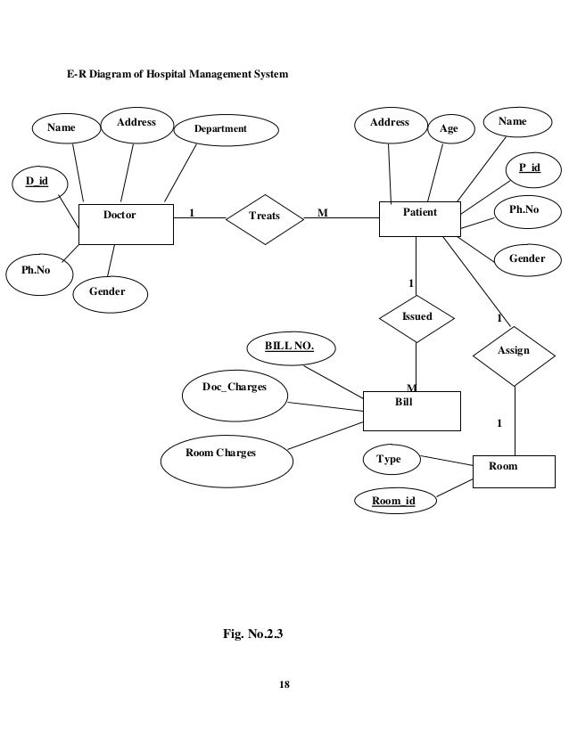

**3.2 DFD**

A data flow diagram is graphical tool used to describe and analyze movement of data through a system. These are the central tool and the basis from which the other components are developed. The transformation of data from input to output, through processed, may be described logically and independently of physical components associated with the system.

These are known as the logical data flow diagrams. The physical data flow diagrams show the actual implements and movement of data between people, departments and workstations.

A full description of a system actually consists of a set of data flow diagrams. Using two familiar notations Yourdon, Gane and Sarson notation develops the data flow diagrams. Each component in a DFD is labeled with a descriptive name. Process is further identified with a number that will be used for identification purpose.

The development of DFD’S is done in several levels. Each process in lower level diagrams can be broken down into a more detailed DFD in the next level. The lop-level diagram is often called context diagram.

It consists single process bit, which plays vital role in studying the current system. The process in the context level diagram is exploded into other process at the first level DFD.

The idea behind the explosion of a process into more process is that understanding at one level of detail is exploded into greater detail at the next level. This is done until further explosion is necessary and an adequate amount of detail is described for analyst to understand the process.

**DFD SYMBOLS:**

In the DFD, there are four symbols:

* A square defines a source(originator) or destination of system data
* An arrow identifies data flow. It is the pipeline through which the information flows
* A circle or a bubble represents a process that transforms incoming data flow into outgoing data flows.
* An open rectangle is a data store, data at rest or a temporary repository of data

**DFD (Data Flow Diagrams)**

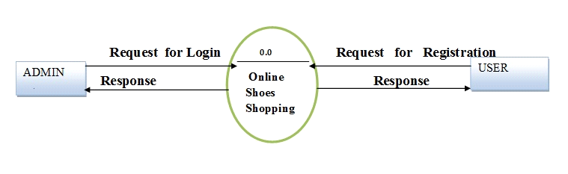

**Login/Sign up Manage Members**

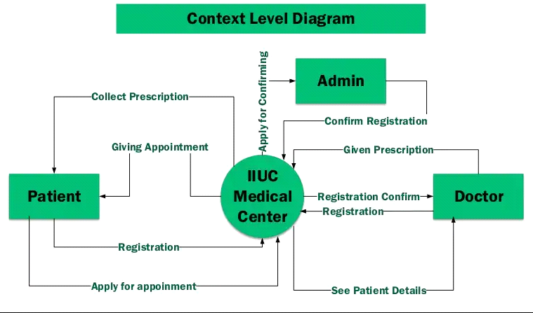

**CHAPTER: 4**

**BACKEND DESIGN**

**4.1 Data Dictionary**

A data dictionary, or Metadata Repository, as defined in the IBM Dictionary of Computing, is a "centralized repository of information about data such as meaning, relationships to other data, origin, usage, and format. The term can have one of several closely related meanings pertaining to databases and database management systems (DBMS):

* A document describing a database or collection of databases.
* An integral component of a DBMS that is required to determine its structure.
* A piece of middleware that extends or supplants the native data dictionary

of a DBMS.

The terms data dictionary and data repository indicate a more general software utility than a catalogue. A catalogue is closely coupled with the DBMS software. It provides the information stored in it to the user and the DBA, but it is mainly accessed by the various software modules of the DBMS itself, such as DDL and DML compilers, the query optimizer, the transaction processor, report generators, and the constraint enforcer. On the other hand, a data dictionary is a data structure that stores metadata, i.e., (structured) data about information. The software package for a stand-alone data dictionary or data repository may interact with the software modules of the DBMS, but it is mainly used by the designers, users and administrators of a computer system for information resource management. These systems maintain information on system hardware and software configuration, documentation, application and users as well as other information relevant to system administration.

If a data dictionary system is used only by the designers, users, and administrators and not by the DBMS Software, it is called a passive data dictionary. Otherwise, it is called inactive data dictionary or data dictionary. When a passive data dictionary is updated, it is done so manually and independently from any changes to a DBMS (database) structure. With an active data dictionary, the dictionary is updated first and changes occur in the DBMS automatically as a result.

Table 4.1 Data Dictionary

|  |  |
| --- | --- |
| **Name** | **Description** |
| id | Identification Of User, Admin, and Jewellery Id of the product |
| email | Mail Address of User |
| mmenu_id | Main menu id of the product |
| Mmenu_name | Menu name of the category of the product |
| Submenu_name | Name of the product link to the main menu |
| Checkout | Check for the buy the product |
| Checked on | Date and time of buy the product by user |

**4.2 Database Tables**

In the “Online Jewellery Shop” there are many modules some of them are as follows:

4.2.1 Admin

It includes admin and Sales Executive. Basically in this table we can store .The information about products ,Categories ,Sub Categories and also information about the users.

Table 4.2 Admin

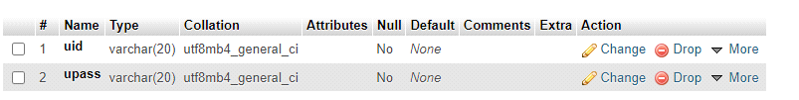

4.2.2 User

This module is used to store the information and details of users. Basically in this table we can store information about the users like Id, Name, Surname, UserName, and Address.

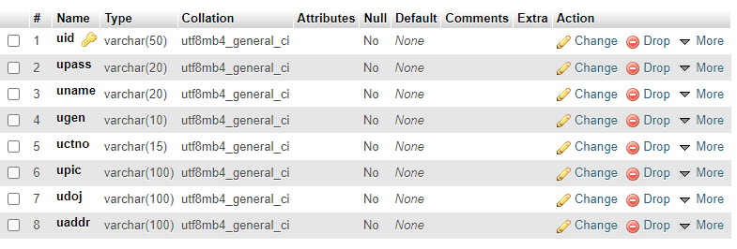

**Appointment Table**

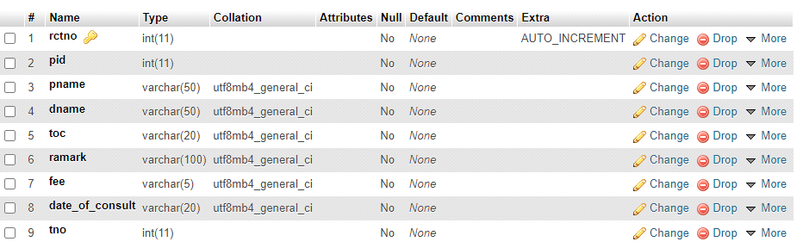

**Doctor Registration Table**

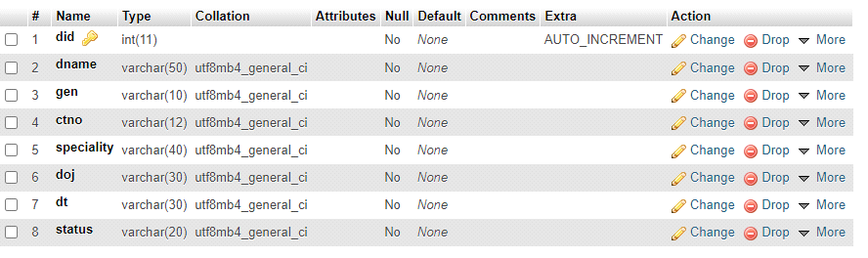

**Patient Registration**

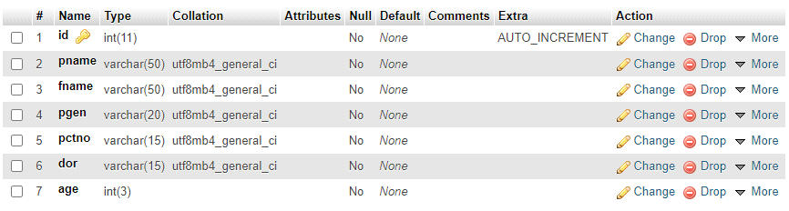

**Token Table**

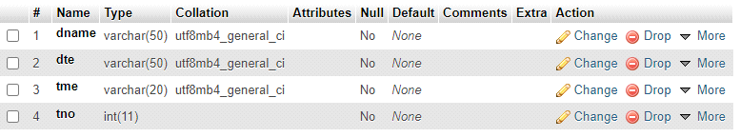

**CHAPTER 5**

**FRONTEND DESIGN**

**Login**

Login is the process by which an individual gains access to a system by identifying and authenticating themselves. Basically using following form employee and admin gain access to the system. The person have to fill the user name and unique password and the press to the submit button.

5.1.2.1 Admin Login

Admin login access the full system and can add or delete employees as well. The admin have to fill the user name and unique password and the press to the submit button to access admin area. Admin view all products details and users details.

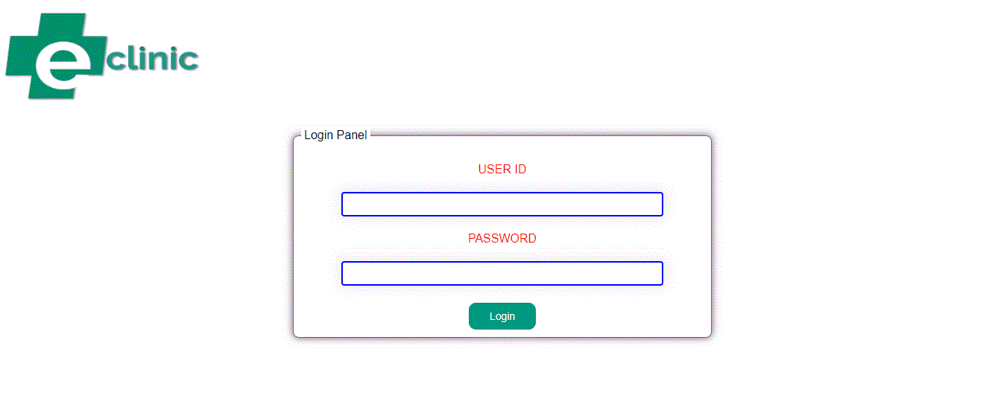

Fig 5.2 Admin Login

**5.1.2.2 User Login**

User Login is the process by which an employee gains access to a

computer system by identifying and authenticating themselves. The user have to fill the user name and unique password and the press to the submit button. User can buy and view products.



**Fig 5.3 User Login**

5.1.3 **Patient Registration**

The User registration form contains a list of fields that is used to input data about customer. To add a new customer we required to fill the given form which contain User name, email, contact number, and address and then submit it.

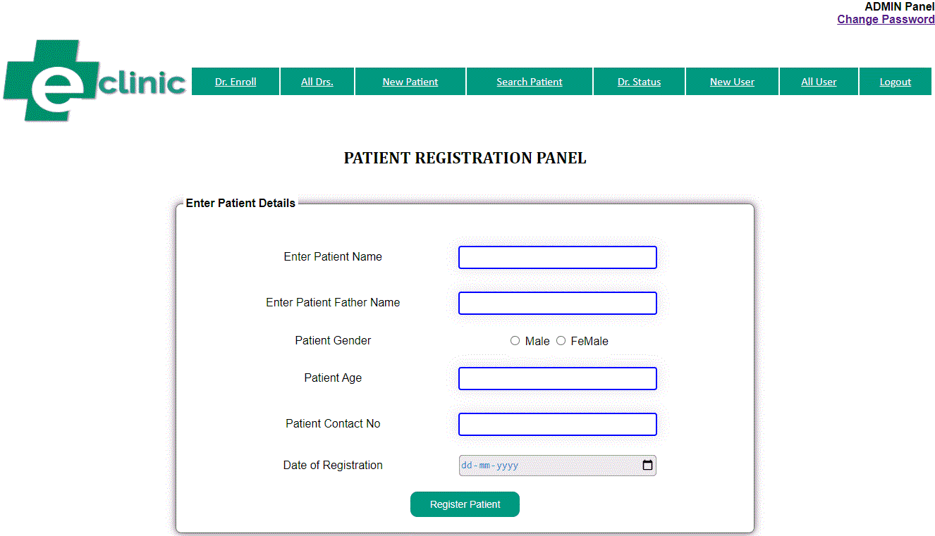

**Fig 5.4 User Registration**

**Appointment Page**

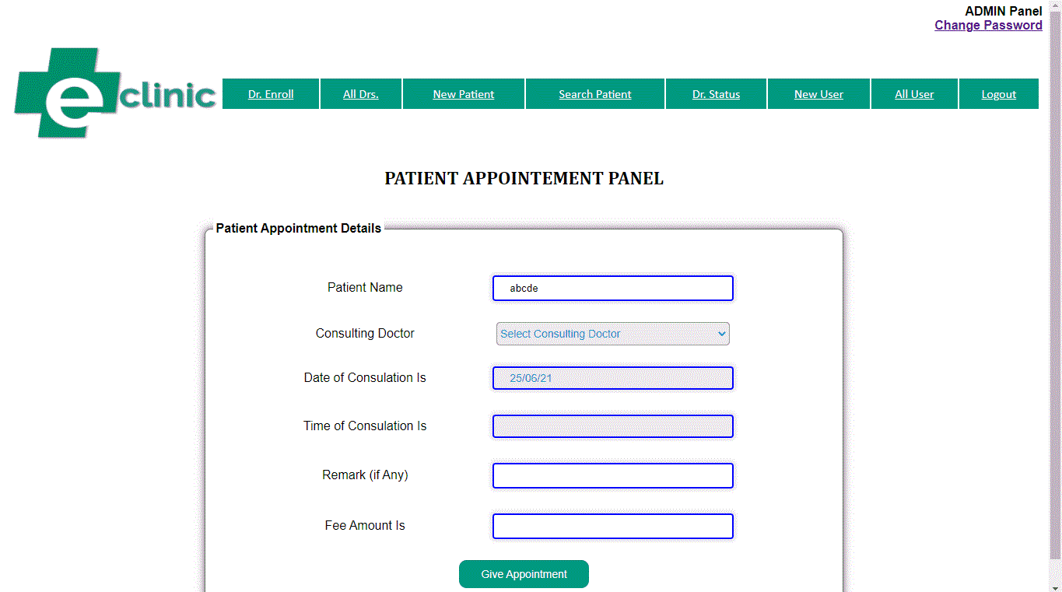

**Change Password Page**

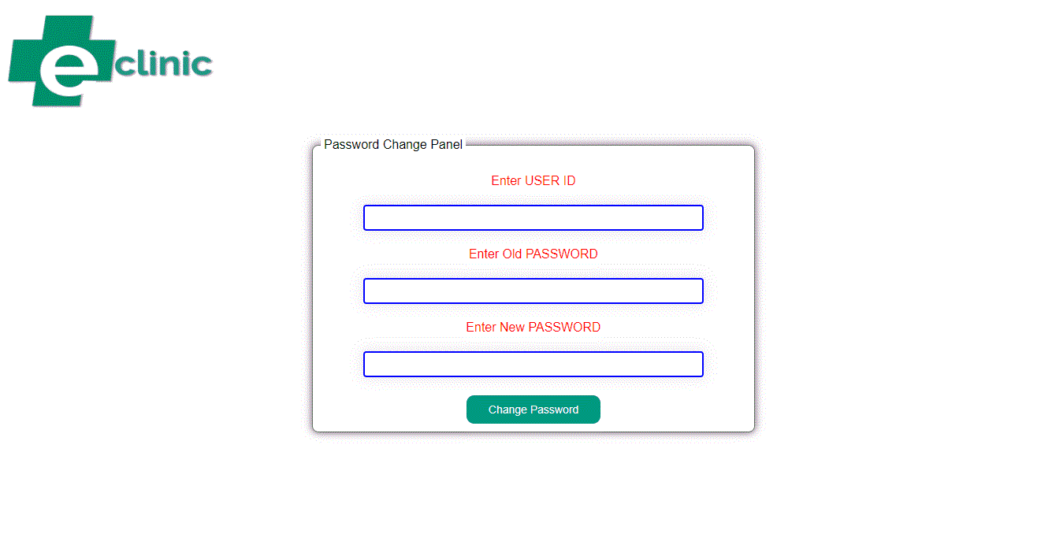

**List of Doctors**

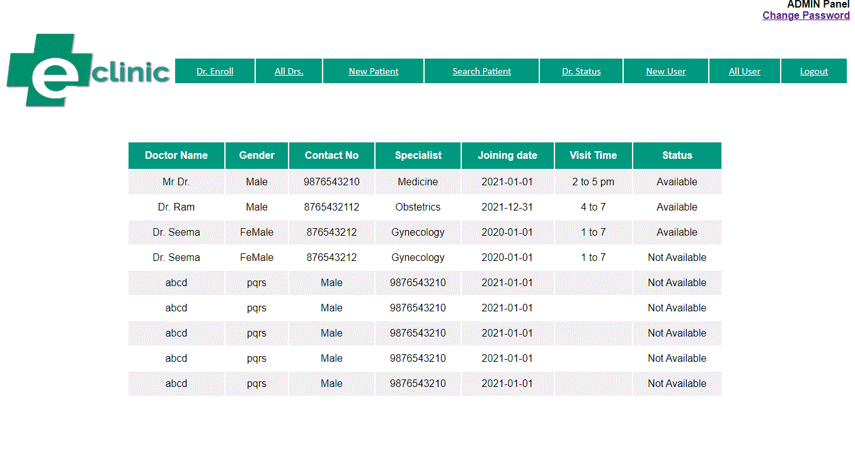

**List of All Users**

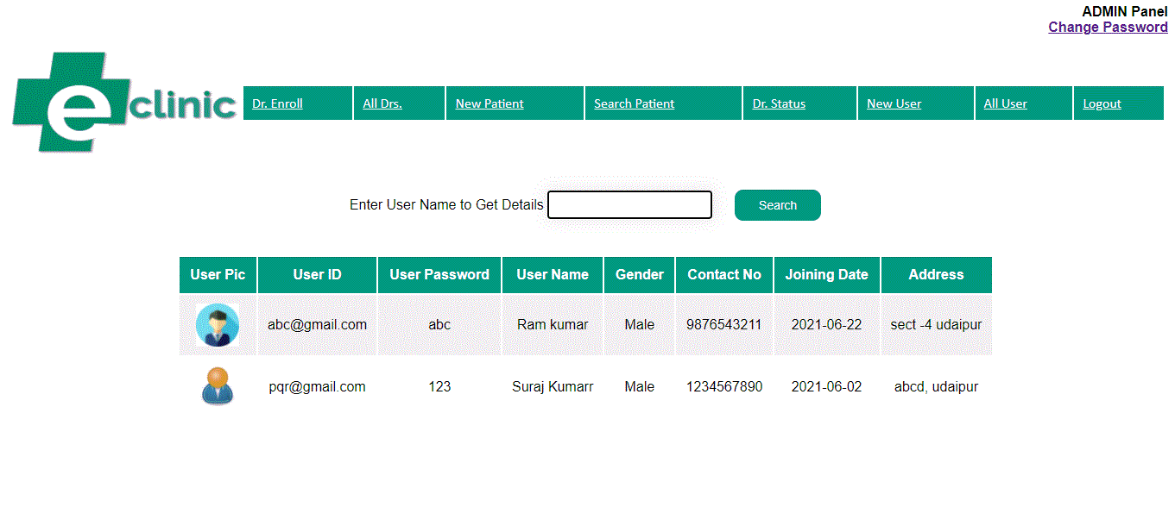

**Patient History**

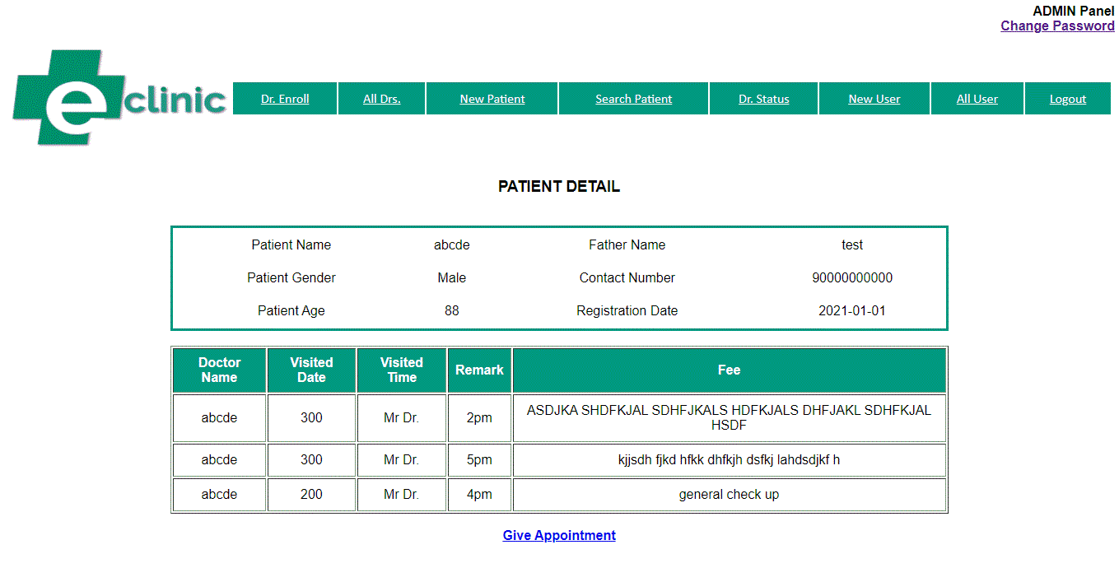

**CHAPTER 6**

**FUTURE SCOPE**

**10.1 Future Scope**

The scope of the project includes that what all future enhancements can be

done in this system to make it more feasible to us:-

SMS features: If patient takes appointment or treatment SMS goes to Patients Cell Phone.

Medical Store: Medical Store Administrator can view suggested prescription through online by entering polyclinic patient ID.

* Patients can view reports, billing, etc
* Consumes less time and reduces human errors.
* Doctors can view patient’s old reports.
* Medical store administrator can view suggested prescription through online by entering patients ID.
* User friendly.

**CHAPTER 7**

**CONCLUSION**

Clinic Management System is a system that can help clinic organization to manage their activity every day. This system will help reduce the problems occur while using the annual system. Furthermore, it is hope that the system can fulfil the user requirement in the future. The next chapter focuses on the literature review and project methodology. It consists of introduction, facts and findings, technique, project methodology, project requirements and lastly project schedule and milestones.